Analysis of FOLH1, PTGS2 and FCGR3A mRNA expression level in primary tumour and metastatic tumour in MSKCC 2010 cohort using R

Gene symbol | Protein name
FCGR3A | CD16
FOLH1 | PSMA
PTGS2 | COX-2

Gene expression data of MSKCC2010 cohort were downloaded from the cBioportal. The MSKCC2010 dataset was analysed in R Studio to investigate the clinical and biological relevance of FCGR3A, FOLH1 and PTGS2 genes in prostate cancer.
The study focused on evaluating the association between gene expression and patient survival, Gleason grade, and metastatic progression. Statistical analyses included Kaplan–Meier survival analysis, ANOVA, and differential expression comparisons between primary and metastatic tumours.

- mRNA expression analysis in primary and metastatic tumours

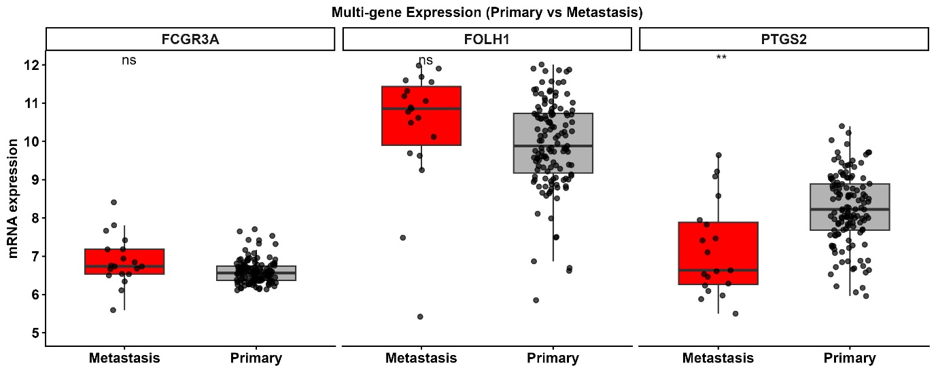

Gene | p.value | t.statistic | significance
FOLH1 | 0.2 | -1.221 | ns
PTGS2 | 0.002 | 3.568 | **
FCGR3A | 0.08 | -1.774 | ns

The comparison between primary and metastatic tumours provided additional insights into the biological role of these genes during cancer dissemination. PTGS2 expression differed significantly between primary and metastatic samples (p = 0.002, t = 3.568). The boxplots indicated that PTGS2 expression was lower in metastatic lesions compared with primary tumours, suggesting that PTGS2 may play a role during the early phases of tumour development or local progression rather than in advanced metastatic disease. FCGR3A showed a non-significant trend toward differential expression between primary and metastatic samples (p = 0.09), whereas FOLH1 did not display statistically significant differences (p = 0.2).

- Gleason scores in primary tumours

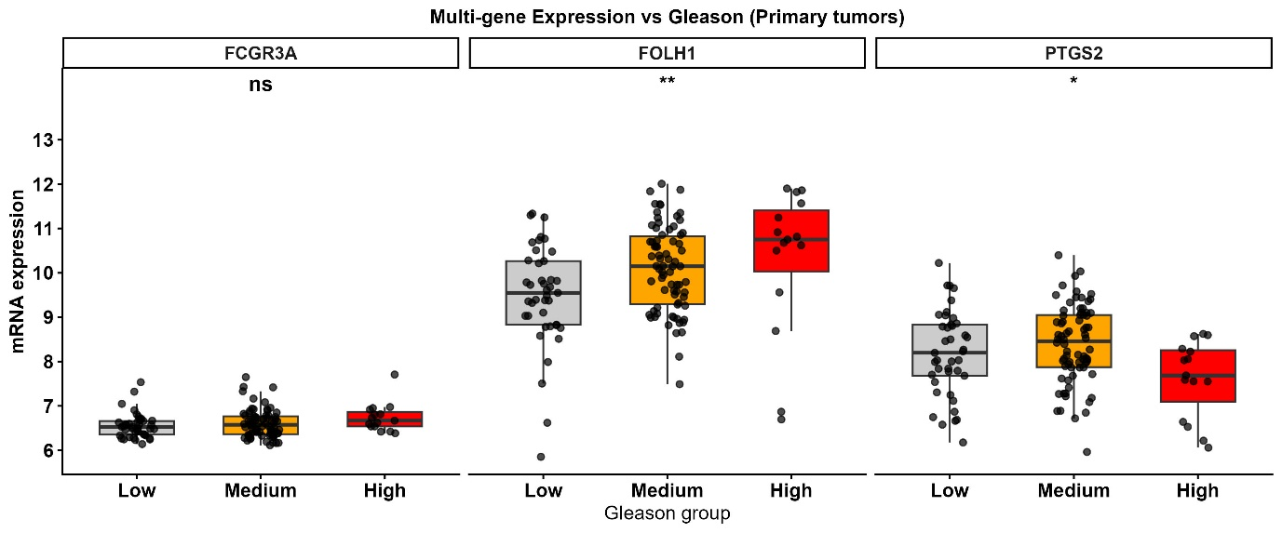

To further evaluate the relationship between gene expression and tumour aggressiveness, expression levels were compared across Gleason score groups of primary tumours using ANOVA. Significant differences were observed for both FOLH1 and PTGS2. FOLH1 demonstrated a strong association with Gleason grade (F = 4.87, p = 0.009), with expression levels increasing progressively in tumours with higher Gleason scores. This observation is consistent with the established role of FOLH1, also known as PSMA, as a marker associated with prostate cancer progression and aggressiveness. PTGS2 also displayed significant variation among Gleason groups (F = 4.73, p = 0.010). However, the expression pattern appeared more heterogeneous, with lower expression observed in the high-grade tumours compared with intermediate groups, suggesting a more complex involvement of PTGS2 during tumour progression. FCGR3A did not show statistically significant differences across Gleason categories (F = 1.48, p = 0.231), indicating a weaker relationship with histopathological grade.

- Survival study via Kaplan-Meier curve

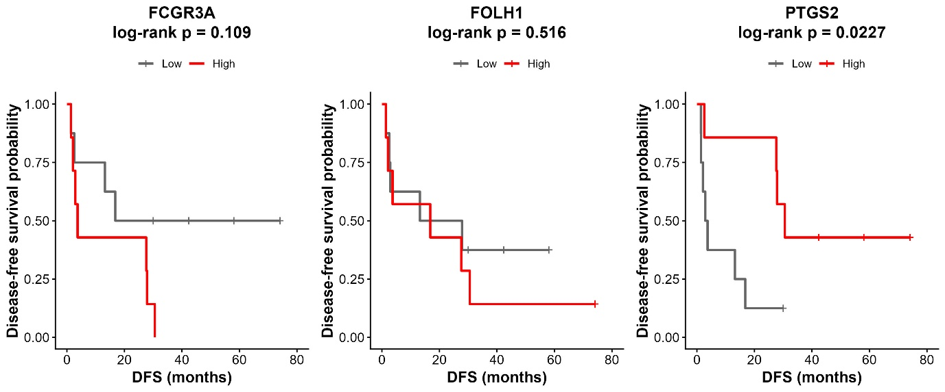

Gene | Test | Chi_Square | df | Sig
FCGR3A | Log Rank (Mantel-Cox) | 2.571 | 1 | 0.1
FOLH1 | Log Rank (Mantel-Cox) | 0.421 | 1 | 0.5
PTGS2 | Log Rank (Mantel-Cox) | 5.193 | 1 | 0.02 *

The survival analysis revealed distinct patterns among the three genes. PTGS2 showed a statistically significant association with patient survival, with a p-value of 0.0018. The Kaplan–Meier curves demonstrated that patients with high PTGS2 expression had a markedly different survival probability compared with those with low expression, suggesting that PTGS2 may be involved in aggressive tumour behaviour and disease progression. In contrast, FOLH1 showed only a non-significant trend toward survival differences (p = 0.14), while FCGR3A showed no association with survival outcomes (p = 0.48). These findings indicate that PTGS2 may have greater prognostic relevance in the MSKCC2010 cohort compared with the other two genes analysed.

- Heatmaps

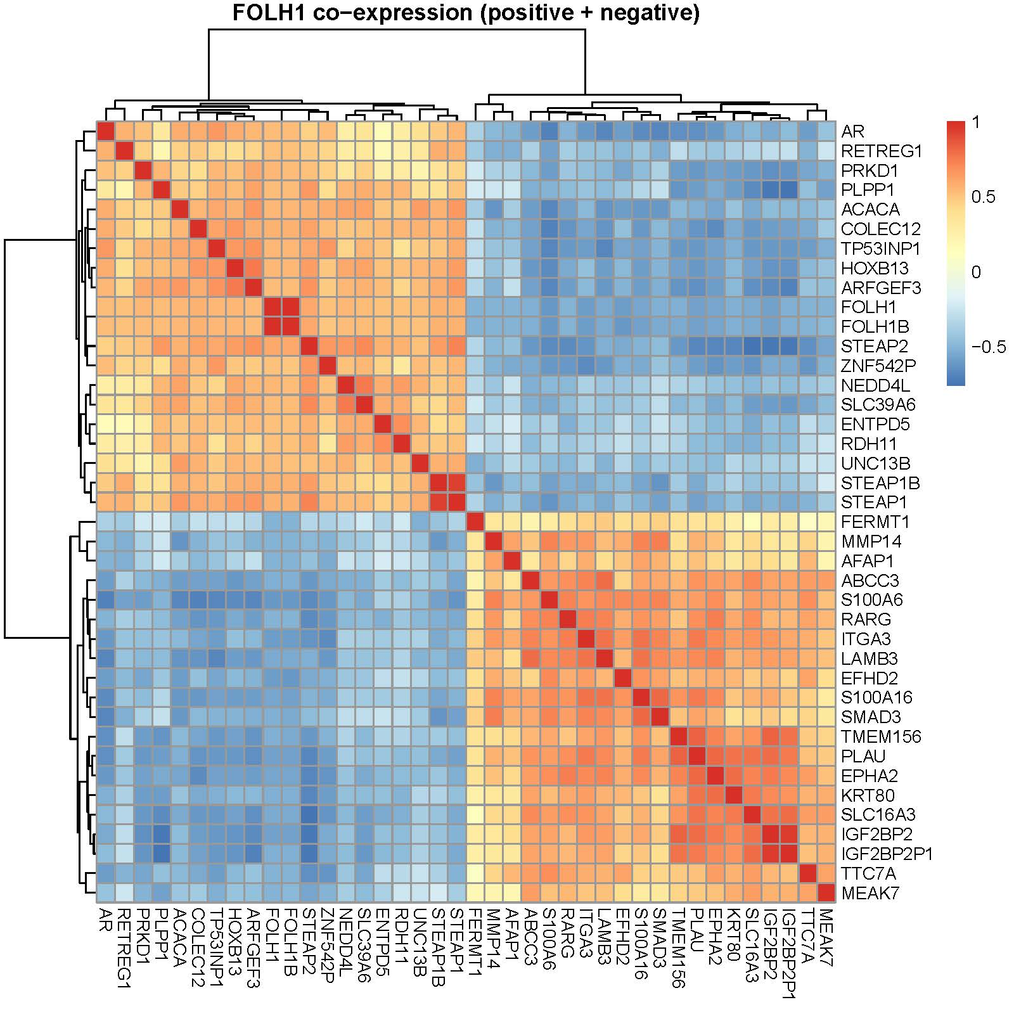

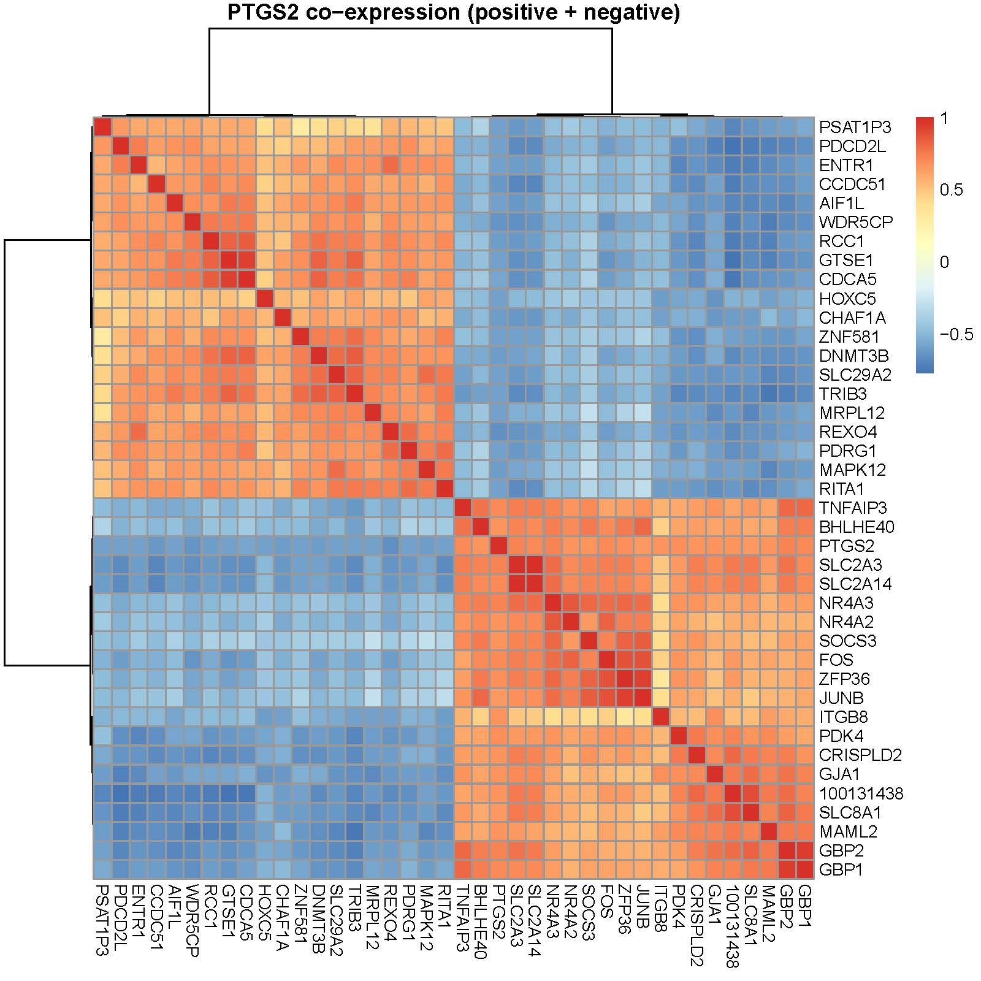
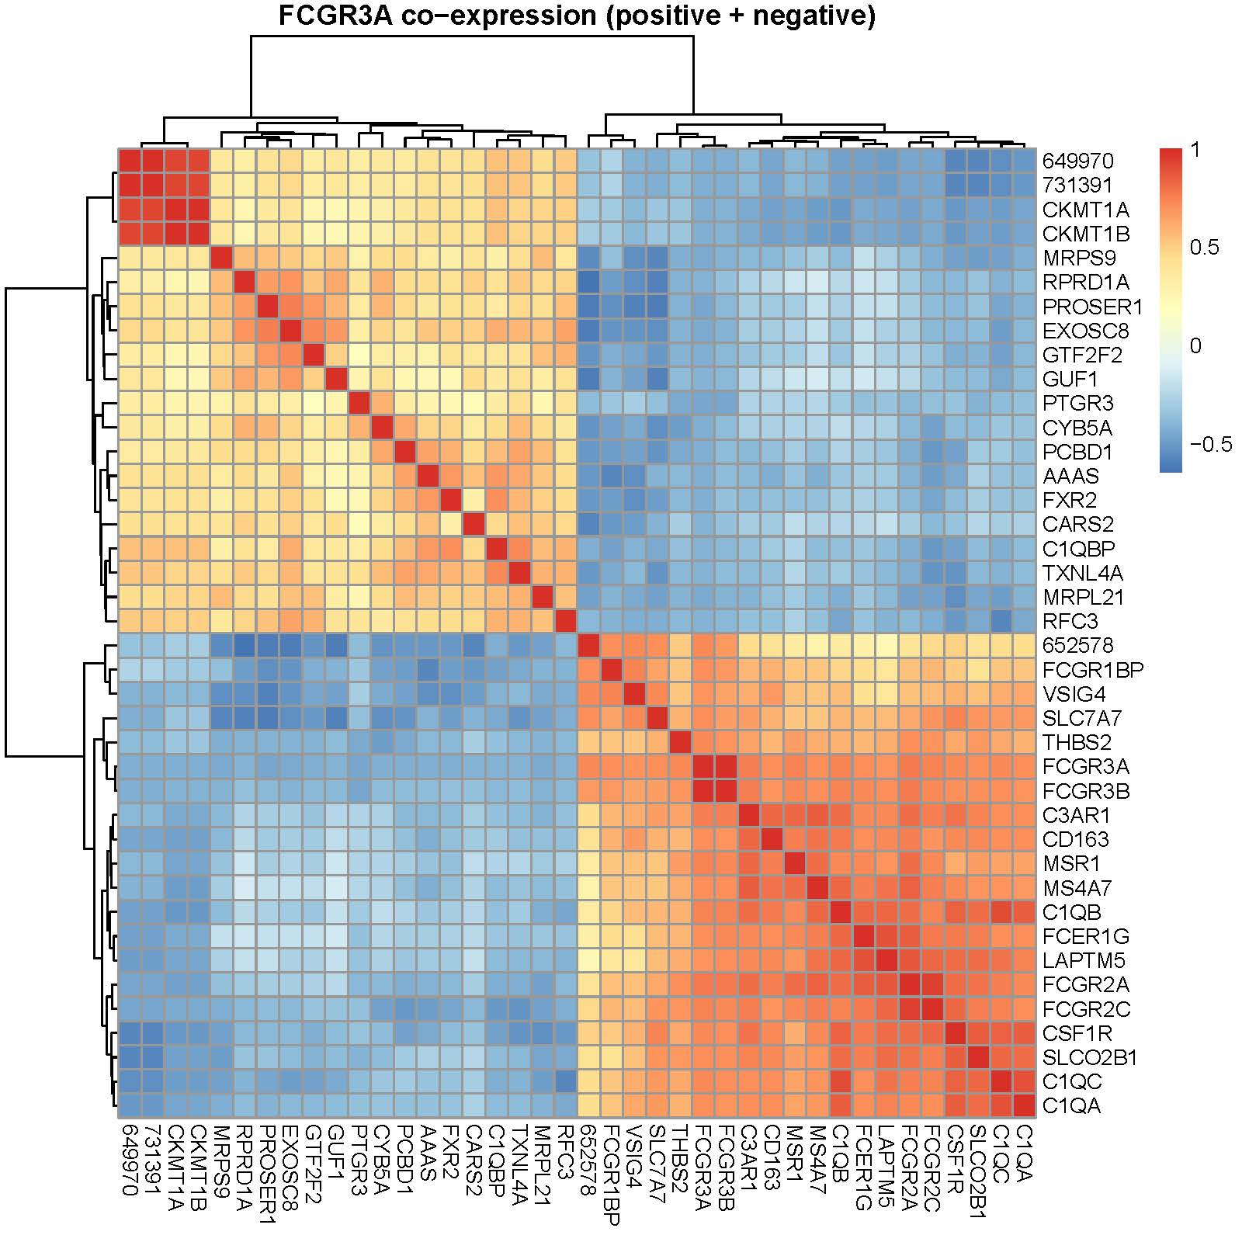

Conclusions
Overall, the results identify PTGS2 as the most clinically relevant gene among those investigated in this study. PTGS2 was significantly associated with patient survival, Gleason grade, and metastatic status, supporting its potential role as a prognostic biomarker in prostate cancer. FOLH1 appeared to be strongly associated with tumour grade, reinforcing its known importance as a marker of aggressive disease. In contrast, FCGR3A did not demonstrate robust statistical associations within this dataset, suggesting a more limited role in prostate cancer progression in the MSKCC2010 cohort.
In conclusion, the present analysis highlights the potential importance of PTGS2 and FOLH1 in prostate cancer biology. PTGS2, in particular, emerged as a promising biomarker linked to prognosis and disease progression, while FOLH1 confirmed its association with tumour aggressiveness.
Further validation studies using independent patient cohorts and multivariate analyses are necessary to confirm these findings and clarify the molecular mechanisms underlying the observed associations.

